**Government Arts & Science College**

**Anthiyur – 638 501**

**Department of Computer Science**

**Sales Force Developer with­­ Agent Blazer Champion**

**Medical Inventory Management**

**Team Leader : Tamilselvan S**

**Team Members : Rajesh V**

**Mayilraj M**

**Nirmalraj S**

**1.Introduction:**

# Project Overview:

The **Medical Inventory Management System** is a comprehensive Salesforce-based solution developed to digitize and streamline the management of medical supplies in healthcare facilities. The system addresses common inventory challenges such as manual errors, stockouts, and expired medicines by offering a real-time, automated approach to inventory control.

Designed with usability and efficiency in mind, the system provides features such as barcode scanning, real-time stock level tracking, automatic expiry alerts, and detailed inventory reporting. It supports role-based access, ensuring that pharmacists, doctors, and administrators can securely manage and view inventory according to their specific roles.

This solution enables healthcare providers to:

* Maintain accurate records of stock levels and item details.
* Monitor expiry dates to prevent the usage of outdated medical products.
* Manage supplier and purchase order information efficiently.
* Access inventory data from multiple devices through a user-friendly interface.

By integrating automation into medical inventory operations, this project aims to enhance accuracy, reduce waste, and improve the overall efficiency and safety of healthcare supply management.

# Purpose

The primary purpose of the Medical Inventory Management System is to offer healthcare facilities an intelligent, automated platform for effectively managing their medical inventory. The system is developed to:

* Enable accurate and real-time tracking of medical stock levels.
* Prevent critical stockouts of essential medicines and supplies.
* Minimize wastage by promptly identifying items nearing expiration.
* Provide insightful reports and analytics to support informed decision-making.
* Simplify procurement through restock alerts and purchase order tracking.
* Promote patient safety by ensuring the timely availability of necessary medicines.

In essence, this project is intended to improve the operational workflows within healthcare settings, reduce inventory-related risks, and support high-quality healthcare service delivery through efficient supply chain management.

**2.Ideation Phase**

# Brainstorming:

In the **Medical Inventory Management System** project, the ideation phase encourages the generation of a wide range of ideas without initially judging their feasibility. The focus is on quantity over perfection, embracing unconventional or out-of-the-box solutions. These raw ideas form the foundation for robust, scalable, and innovative Salesforce-based solutions. Team collaboration helps filter and refine ideas into practical implementations tailored for medical inventory need

# Empathy Map:

TThe empathy map centers on understanding the core needs, emotions, and challenges faced by key stakeholders, such as pharmacists, inventory managers, and hospital staff who rely on the system.

* **Says:** Users emphasize the importance of accurate stock tracking, expiry date monitoring, low-stock alerts, efficient reporting, and easy data entry.
* **Thinks:** They are concerned about missing expiry dates, manual data errors, and compliance with healthcare regulations.
* **Does:** Regularly monitor inventory levels, update records, generate reports, communicate with suppliers, and prepare for audits.
* **Feels:** Anxious about shortages, frustrated with complex systems, relieved when alerts work properly, and confident when the system is efficient.

This empathy map helps align the solution to the real-world pain points of users, resulting in increased system usability, trust, and satisfaction

# Problem Statement:

While building the Medical Inventory Management System using Salesforce, users often face difficulties in generating accurate and dynamic reports due to:

* Complex data relationships
* Manual report creation
* Limited native customization options

These limitations can lead to:

* Incomplete inventory visibility
* Delayed expiry tracking
* Missed stock alerts

Such challenges impact decision-making, regulatory compliance, and patient safety. Therefore, there is a critical need for a **streamlined, automated, and real-time reporting system** within Salesforce that ensures accurate tracking, timely notifications, and reliable inventory management.

**3. Requirement Analysis:**

# Customer Journey map:

The customer journey map outlines the key stages a typical user (e.g., pharmacist, hospital staff) goes through when interacting with the Salesforce-based inventory system:

1. **Awareness & Consideration:**  
   Users identify the limitations of manual inventory methods and explore the system’s benefits in improving accuracy and automation.
2. **Onboarding & Initial Use:**  
   Users are introduced to the Salesforce platform, undergo brief training, and begin using features like stock entry, reporting, and expiry alerts. Some initial learning challenges are common.
3. **Issue Resolution & Support:**  
   Users may face issues like report generation errors or navigation difficulties and rely on support for resolution. Timely help builds user trust.
4. **Adoption & Loyalty:**  
   As users gain confidence, they depend more on the system. Consistent performance and continuous improvements can lead to high satisfaction and advocacy for the platform.

**Key Insights:**  
Seamless onboarding, intuitive interface, timely support, and reliable real-time data are essential to maximize user satisfaction and system adoption.

# Solution Requirements:

**1. Functional Requirements**

* Real-time inventory tracking with batch numbers and expiry date monitoring
* Automated alerts for low stock levels and approaching expiries
* Custom real-time reports for inventory status, audits, and expiry tracking
* Barcode scanning for quick and accurate data entry
* Role-based access control for pharmacists, auditors, and managers
* Automated workflows for restocking and expiry item handling
* Mobile accessibility for updates and reporting
* Optional integration with supplier/vendor systems

**2. Non-Functional Requirements**

* Fast system performance and real-time response
* User-friendly interface with minimal training needed
* Scalability for expanding inventory and user base
* High system availability and minimal downtime
* Strong data protection and access security
* Easy to maintain and update with minimal technical intervention

# Technology stack

**Platform:** Salesforce Developer Edition  
**Key Tools & Technologies:**

* **Objects & Schema Builder** for data modeling
* **Process Builder / Flow** for workflow automation
* **Apex** for custom logic and backend processes
* **Visualforce / Lightning Components** for UI customization
* **Reports & Dashboards** for analytics
* **Data Loader** for bulk data operations
* **Salesforce Mobile App** for accessibility
* **External APIs (optional)** for supplier integration
* 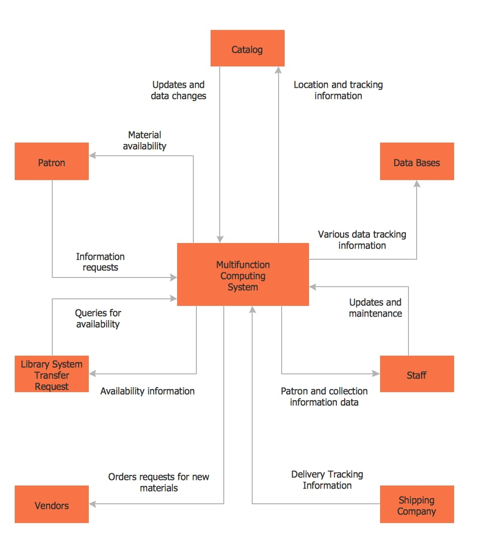Data Flow Diagram:

**4.Project Desing:**

# Problem Solution Fit:

Problem:

Healthcare facilities often face:

* Stock shortages.
* Expired medicines going unnoticed.
* Manual tracking errors.
* Inefficient inventory reporting.

Solution:

A Medical Inventory Management System that:

* Tracks stock levels in real-time.
* Sends automated alerts for low stock and nearing expiry.
* Provides accurate reporting and analytics.
* Reduces manual errors with barcode scanning and digital records.

Problem-Solution Fit:

You achieve fit when:

* Healthcare staff find the system easy to use and it saves their time.
* Expiry alerts reduce medicine wastage.
* Stock shortage incidents drop significantly.
* Decision-makers trust the reports and use them for ordering and planning.

Problem-Solution Fit is when medical inventory system genuinely solves the pain points of medicine tracking, stock management, and reporting in healthcare settings, and the users (like pharmacists, nurses, and admins) are happy with the solution.

# Proposed Solution:

The Medical Inventory Management System is a smart, digital solution designed to address the common challenges faced by healthcare facilities in managing their medical supplies. Traditional manual tracking methods often lead to stock shortages, unnoticed expiry dates, and reporting errors that can impact patient safety and hospital efficiency. This system offers real-time inventory tracking with automated alerts for low stock and upcoming expiries, ensuring timely replenishment and reducing wastage. It integrates barcode scanning to speed up inventory updates and minimize manual entry errors.

A user-friendly interface makes it simple for healthcare staff, including pharmacists, nurses, and inventory managers, to use the system with minimal training. It also provides detailed reporting and analytics, helping administrators make quick, data-driven decisions regarding procurement and inventory levels. The system supports multi-user access with role-based permissions, ensuring that each user interacts with the system according to their responsibilities. This enhances data security and workflow efficiency.

By digitizing the inventory process, the proposed solution significantly improves accuracy, reduces human error, and helps maintain a safe and well-stocked medical supply chain in healthcare facilities.

# Solution Architecture:

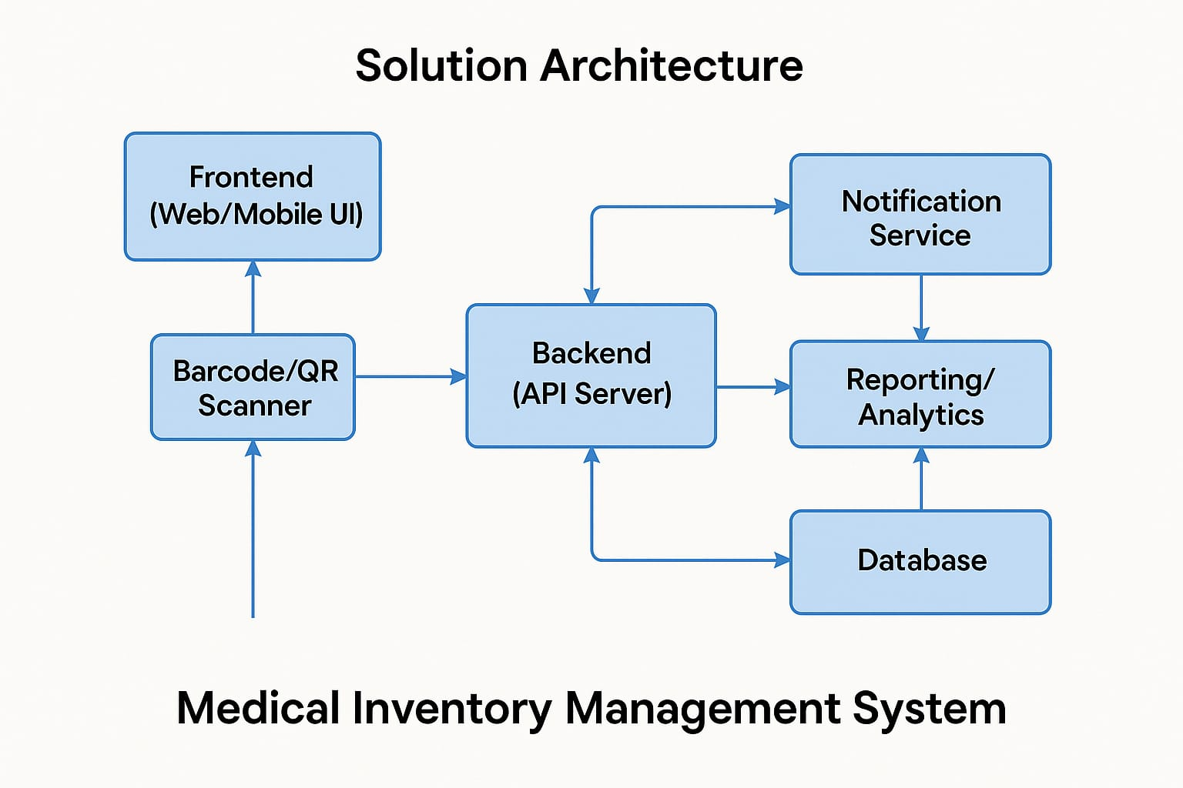

The solution architecture of the Medical Inventory Management System is designed to ensure seamless, secure, and real-time management of medical inventories across healthcare facilities. It is structured into three main layers:

1. Frontend Layer:

The user interface is accessible via both web and mobile applications, providing role-based dashboards for pharmacists, doctors, and administrators. It allows users to view stock levels, receive alerts, and generate reports in a user-friendly environment.

2. Backend Layer:

The backend consists of a RESTful API server that manages business logic, inventory operations, and user authentication. It handles all communication between the frontend and the database and integrates services like email and SMS notifications for timely stock and expiry alerts.

3. Database Layer:

The database securely stores all medical inventory data, including stock details, expiry dates, user roles, and transaction logs. It supports real-time updates and retrievals to ensure accuracy and quick response times.

**5.Project Planning & Scheduling**

# Project Planning:

* Initiation:
* Creating a developer org in salesforce.
* On the signup form, entered the details.
* After Activating the account, we will be having the developer account to create the project.

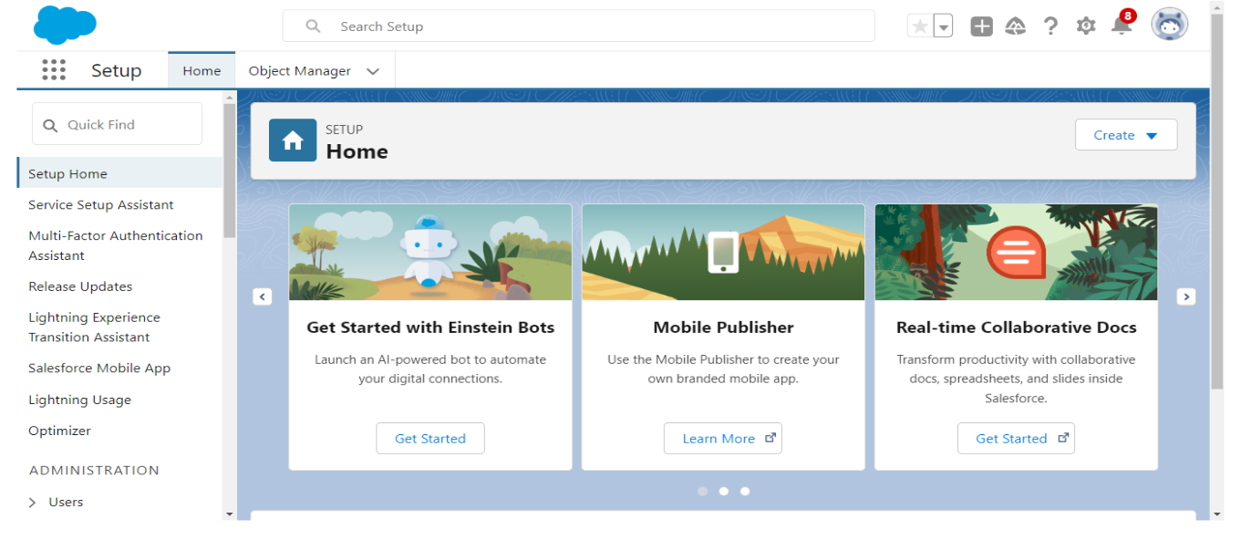

* Planning:

During the planning phase of the **Medical Inventory Management System**, key components and configurations were carefully outlined and implemented to ensure a smooth development and deployment process. The following activities were undertaken:

* **Custom Object Creation:**  
  Developed essential custom objects including **Product**, **Purchase Order**, **Order Item**, **Inventory Transaction**, and **Supplier** to manage various aspects of medical inventory.
* **Tab Configuration:**  
  Created custom tabs for the newly developed objects to enable easy navigation and accessibility within the Salesforce interface.
* **Lightning App Setup:**  
  Designed and configured a dedicated **Lightning App** named *Medical Inventory Management* to group all relevant components, streamlining user access.
* **Field and Layout Customization:**  
  Added custom fields to each object based on functional requirements and tailored **page layouts** to improve user experience and data input efficiency.
* **Compact Layouts:**  
  Defined **compact layouts** for key objects to display critical information in highlights panels, enhancing user visibility in Lightning Experience.
* **Validation Rules:**  
  Implemented **validation rules** in relevant objects (e.g., Employee) to ensure data integrity and prevent invalid entries during record creation or updates.
* **Security & Access Configuration:**  
  Established **Profiles, Roles, Users**, and **Permission Sets** to control access based on user roles such as Pharmacist, Admin, and Inventory Manager.
* **Automation and Reporting:**  
  Developed **Flows** and **Triggers** to automate processes like stock updates and expiry notifications.  
  Created **Reports and Dashboards** to provide real-time insights into inventory status, stock movement, and supplier performance.
* Development:

Creation of Objects:

To create a custom object in Salesforce, navigate to **Setup** from the Salesforce homepage. From the **Object Manager** tab, click on **"Create New Custom Object"**. Fill in the necessary details such as the **Label**, **Object Name**, and **Record Name**, and configure options like **Allow Reports**, **Track Field History**, and **Deployment Status**. Once the details are complete, click **Save** to create the object.

This process was repeated to create all the required objects for the **Medical Inventory Management System**. The following custom objects were created to support the application's functionality:

* **Product** – Stores information about medical items available in inventory.
* **Purchase Order** – Tracks orders placed to suppliers for inventory restocking.
* **Order Item** – Represents individual items within a purchase order.
* **Inventory Transaction** – Logs stock movement such as additions, usage, or removals.
* **Supplier** – Maintains details of vendors supplying medical products.

These objects form the core structure of the system and were further customized with fields, relationships, and automation to suit the medical inventory workflow.

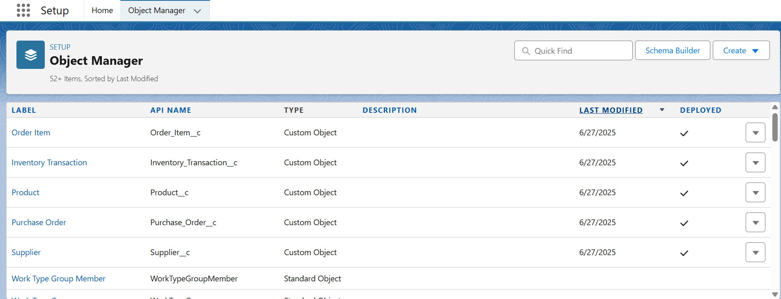

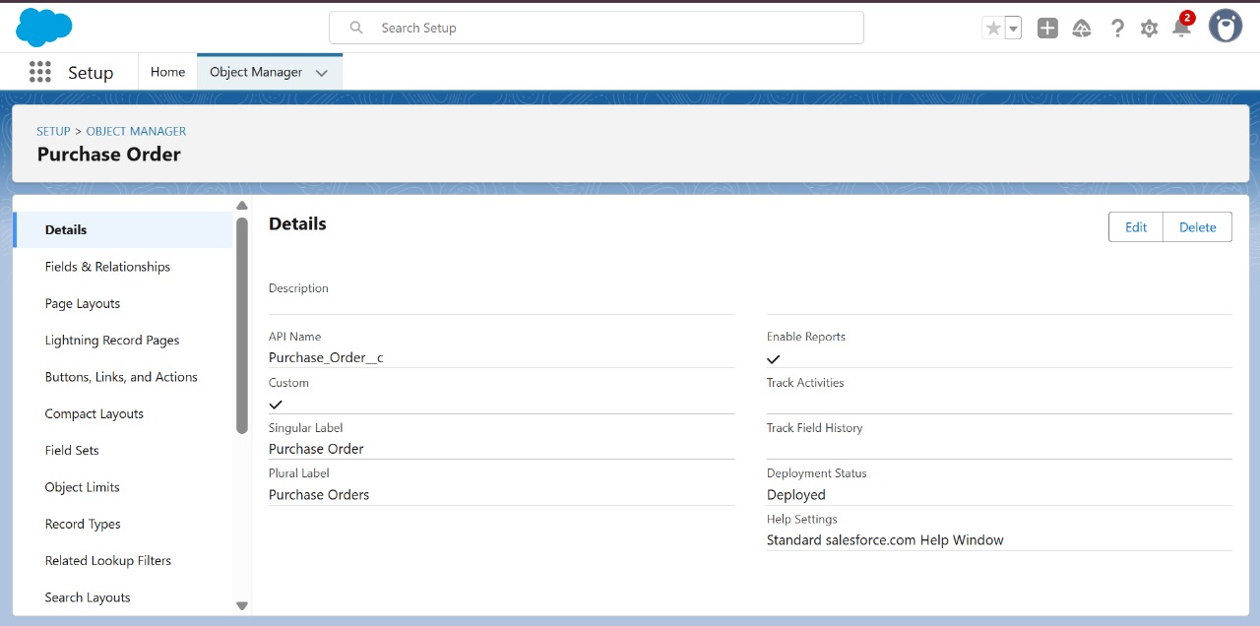

Creation of Tabs:

**Tabs** in Salesforce are used to make the data stored within custom or standard objects easily accessible to users through the user interface. They serve as navigation elements that allow users to view, create, and manage records related to a specific object.

Tabs are a fundamental part of the Salesforce experience, enabling seamless access to different objects without needing to navigate through complex menus. By creating custom tabs for each of the objects—such as **Product**, **Purchase Order**, **Order Item**, **Inventory Transaction**, and **Supplier**—users can quickly access and interact with the data relevant to the **Medical Inventory Management System**.

Tabs not only improve user efficiency but also enhance the overall usability of the application by organizing key modules in a structured, intuitive layout.

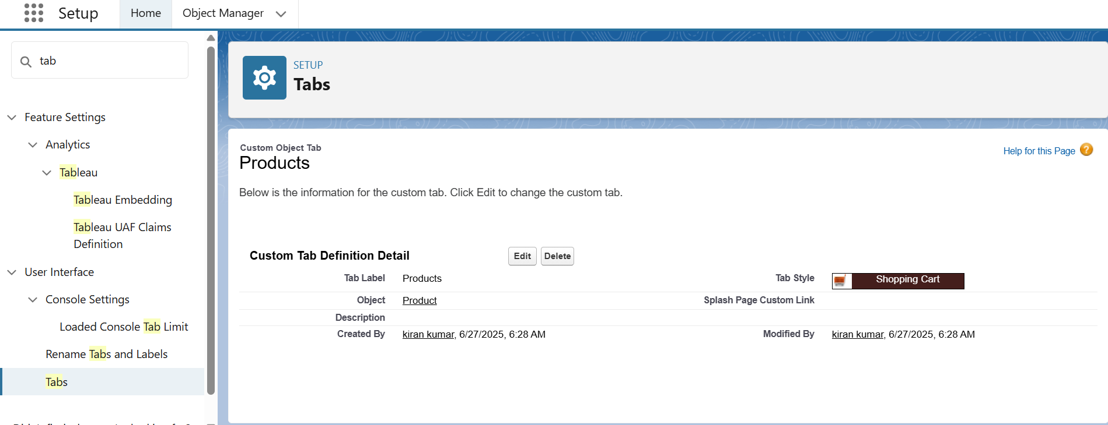

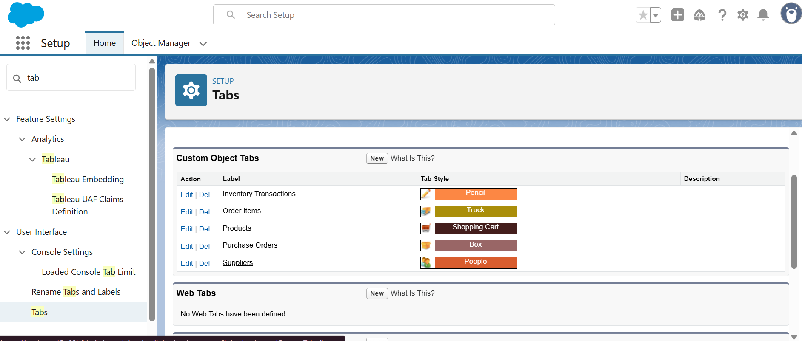

Creating the Lightning App:

A **Lightning App** in Salesforce is a customized collection of components—such as standard and custom objects, tabs, utilities, and tools—designed to streamline workflows and enhance the user experience for a specific business function. Lightning Apps provide a more modern, efficient, and role-specific interface compared to traditional Salesforce apps.

For the **Medical Inventory Management System**, a dedicated Lightning App was created to bring together all relevant components into a unified workspace.

**Steps to Create the Lightning App:**

1. Go to **Setup**, and in the **Quick Find** box, type **App Manager**, then select it.
2. Click **New Lightning App**.
3. Enter the **App Name** as **Medical Inventory Management**.
4. Configure the app settings, including the branding, navigation style, and utility bar (if needed).
5. Add the required **objects and tabs** such as Product, Purchase Order, Inventory Transaction, Order Item, and Supplier.
6. Assign the app to relevant user profiles to ensure appropriate access.

This app serves as the central hub for all medical inventory operations, allowing users to navigate quickly and efficiently between various modules.

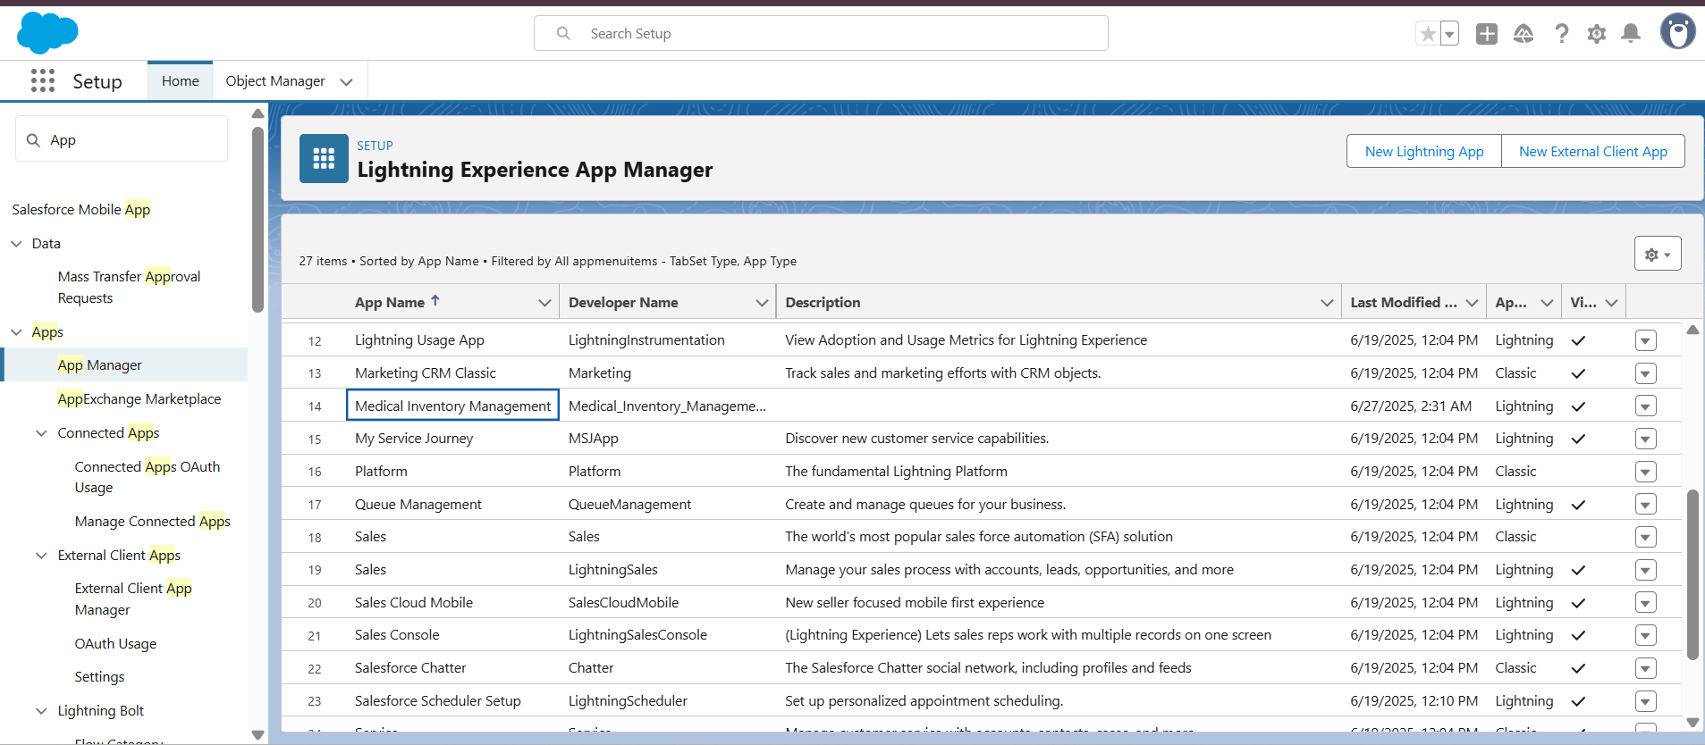

**Creating Fields in Objects:**

**Creating a Text Field in Product Object:**

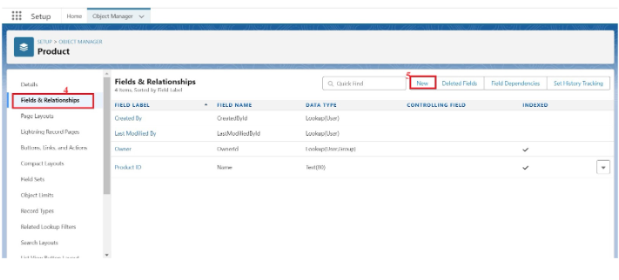

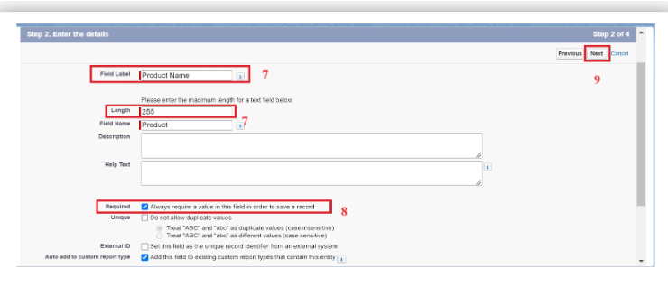

**Creating a Text area Field in Product Object:**

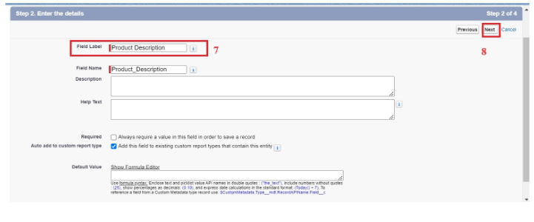

**Created fields in Product Object:**

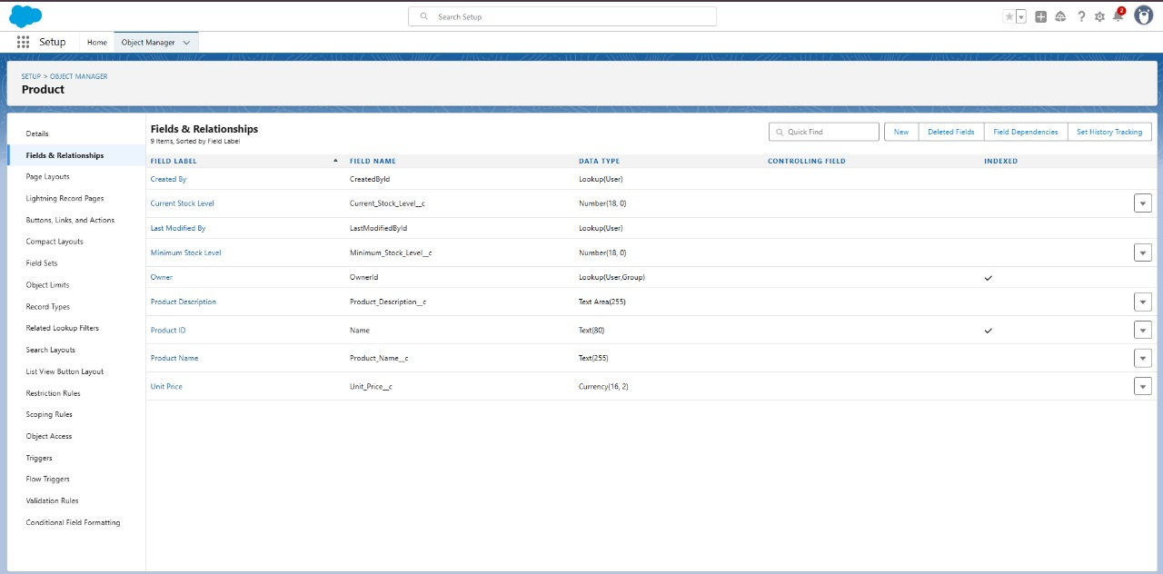

**Creating Lookup Relationship in Purchase Order Object:**

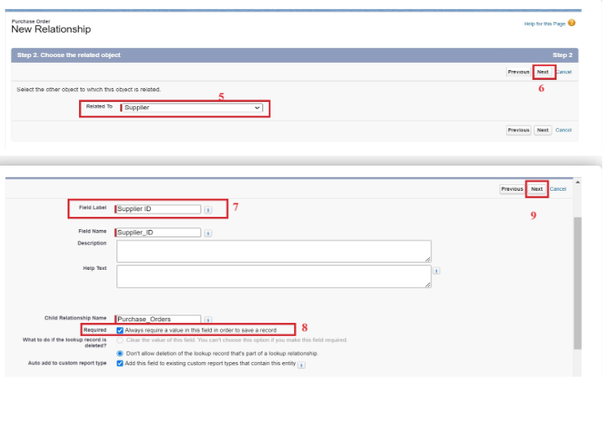

**Created Fields in Purchase Order Object:**

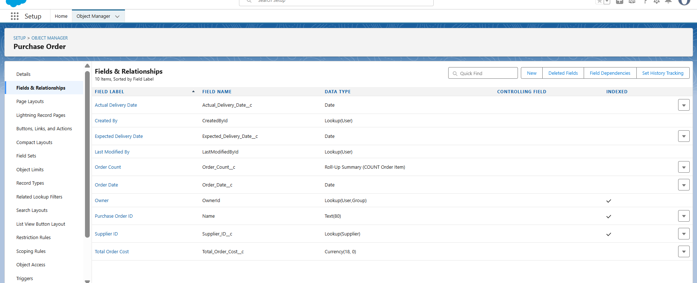

**Creating a Unit Price Formula Field in Order Item object:**

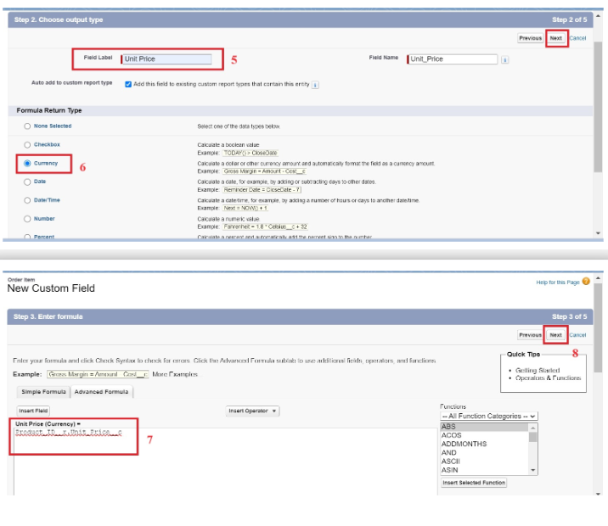

**Created Fields in Order Item Object:**

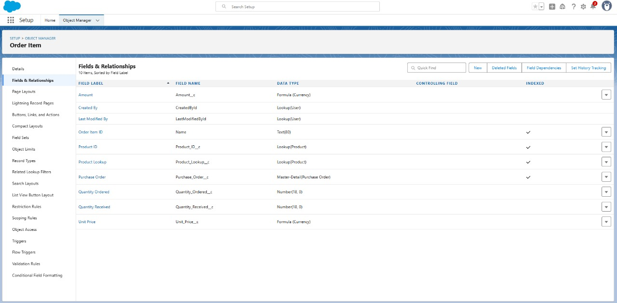

**Created Fields in Inventory Transaction Object:**

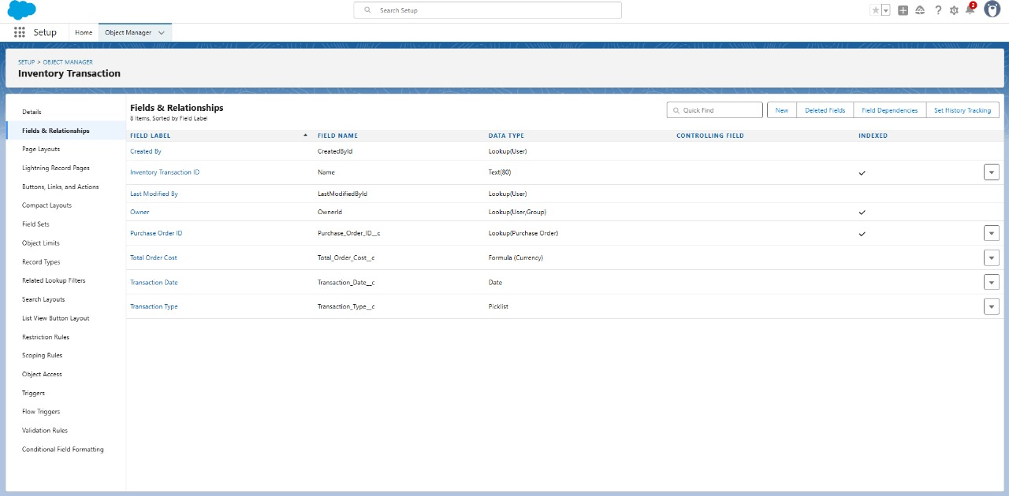

**Created Fields in Supplier Object:**

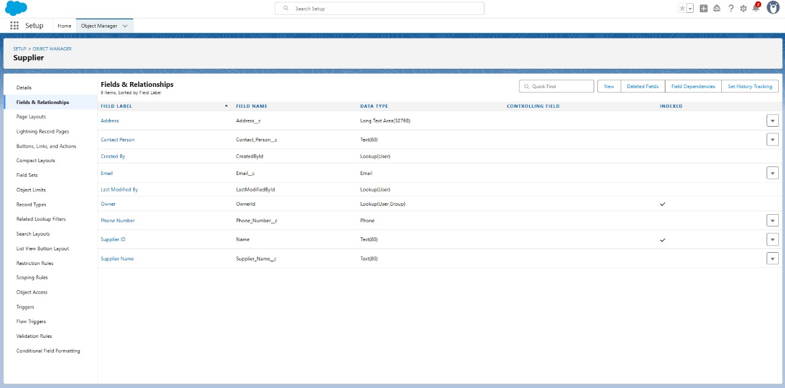

**Creating page layouts in Created objects:**

**Created Page layout in Product object:**

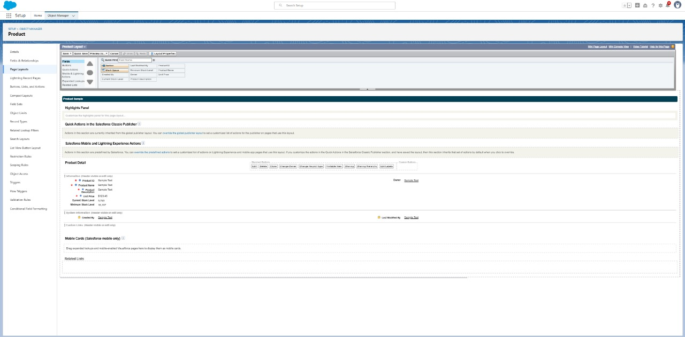

**Created Page layout in Order Item object:**

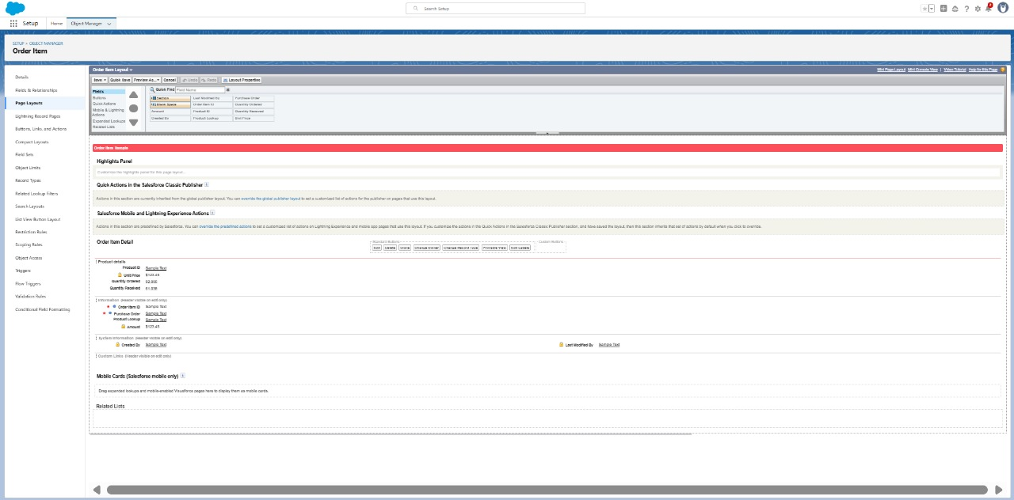

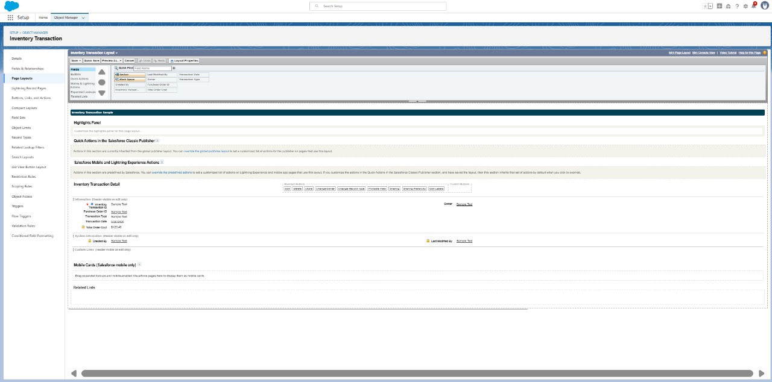 **Created Page layout in Inventory Transaction object:**

**Created Page layout in Supplier object:**

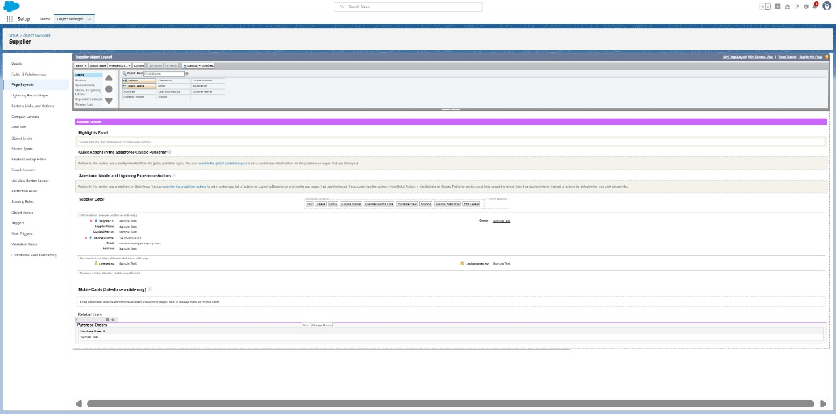

**Compact Layouts:**

Compact layouts display a record’s key fields at a glance, providing important information quickly without needing to open the record.

**Created Compact layout in Product object:**

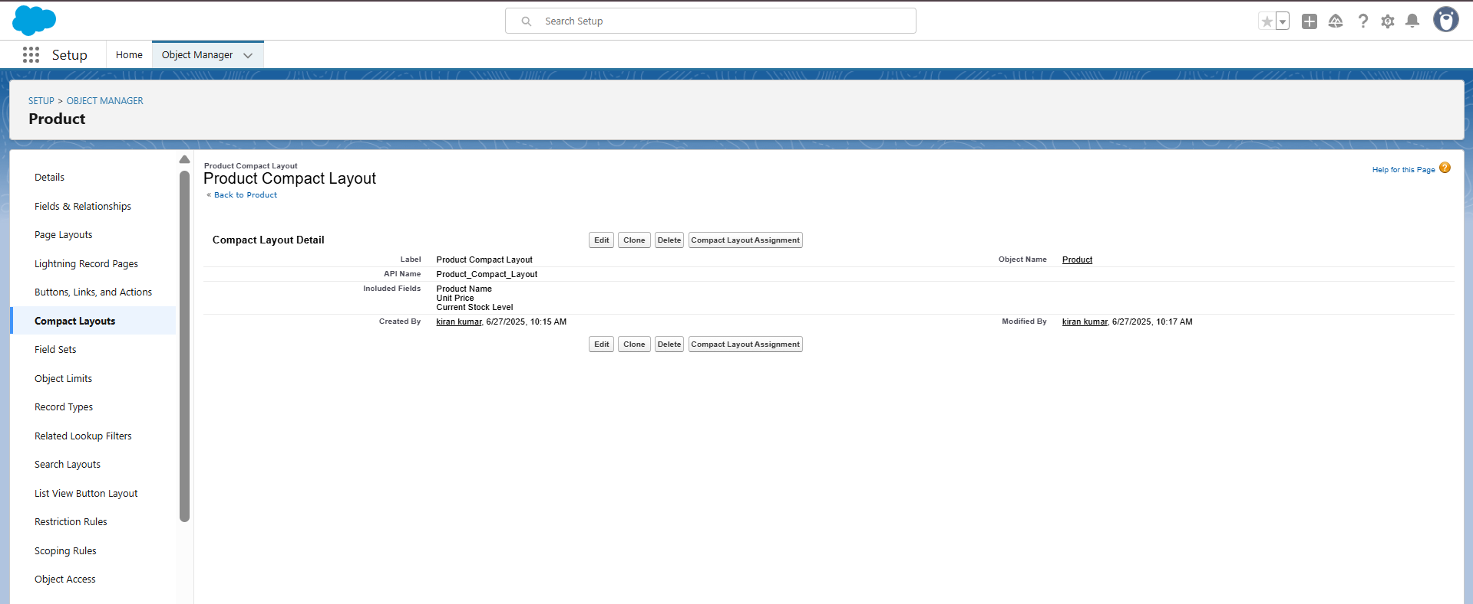

**Created Compact layout in Purchase Order object:**

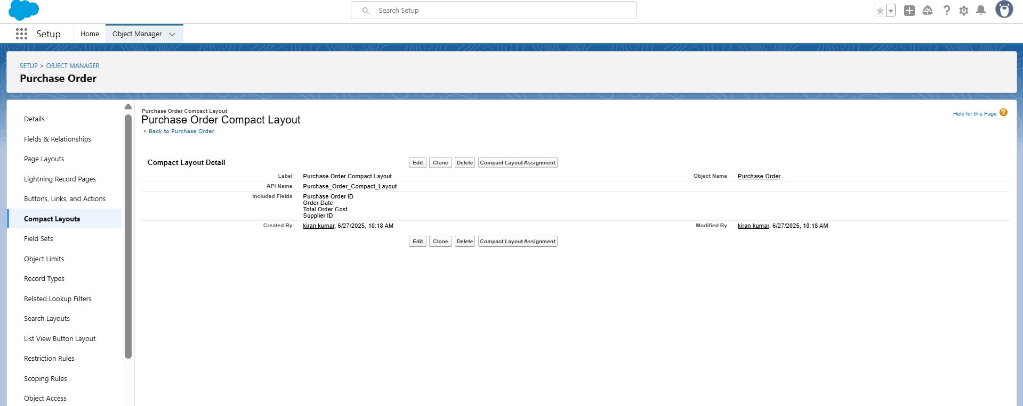

**creating an Expected Delivery Date Validation rule to Employee Object:**

Validation rules in Salesforce are used to ensure data integrity by preventing users from saving invalid data in records. They consist of a formula or expression that evaluates the data in one or more fields and return a value of true or false. When the rule's criteria are met (i.e., the expression evaluates to true), an error message is displayed, and the user is prevented from saving the record until the issue is resolved.

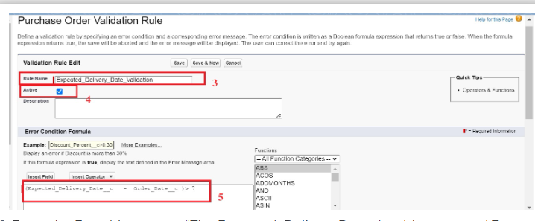

**Created Validation Rule in Purchase Order object:**

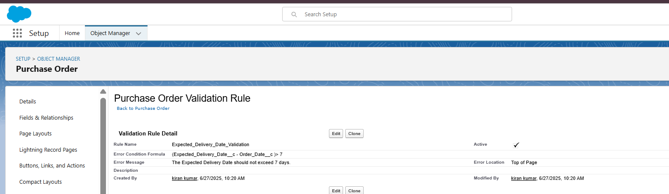

**Profiles:**

Profiles in Salesforce are fundamental to the platform's security model, defining what users can do within the organization. Profiles control a user’s permissions to objects, fields, tabs, apps, and other settings. Each user in Salesforce must be assigned a profile, and the profile assigned to a user determines what they can see and do in the system.

**Created Profiles:**

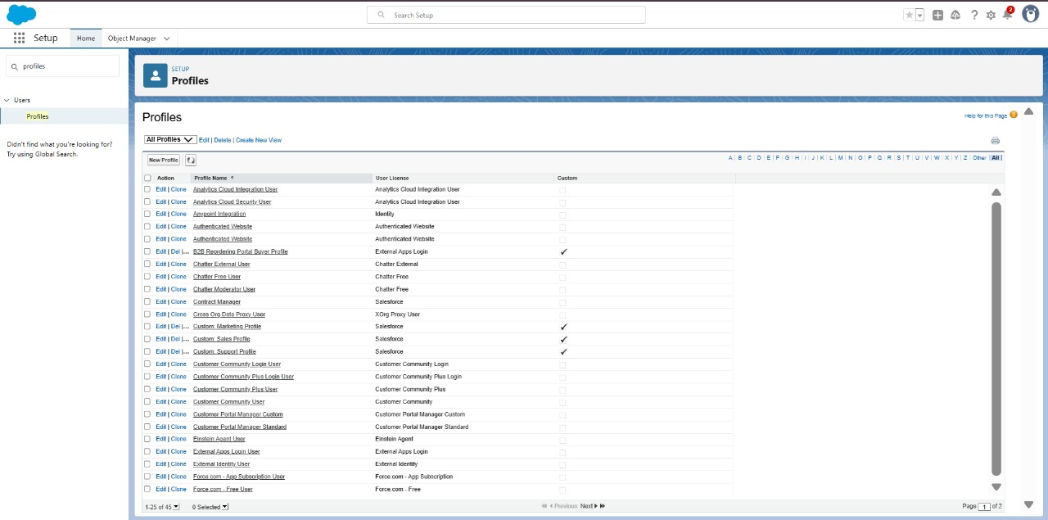

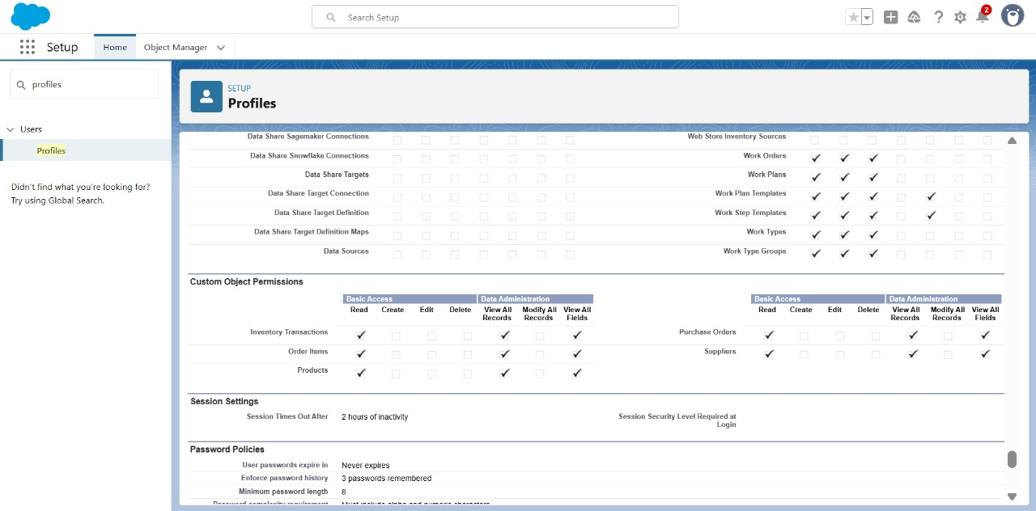

**Roles:**

Roles in Salesforce are used to control record-level access and define the hierarchy of an organization, determining the level of visibility and sharing of records among users. Roles work in conjunction with profiles to provide a robust security model. While profiles control what actions users can perform (object and field permissions), roles control which records users can see based on their position in the hierarchy.

**Created Roles:**

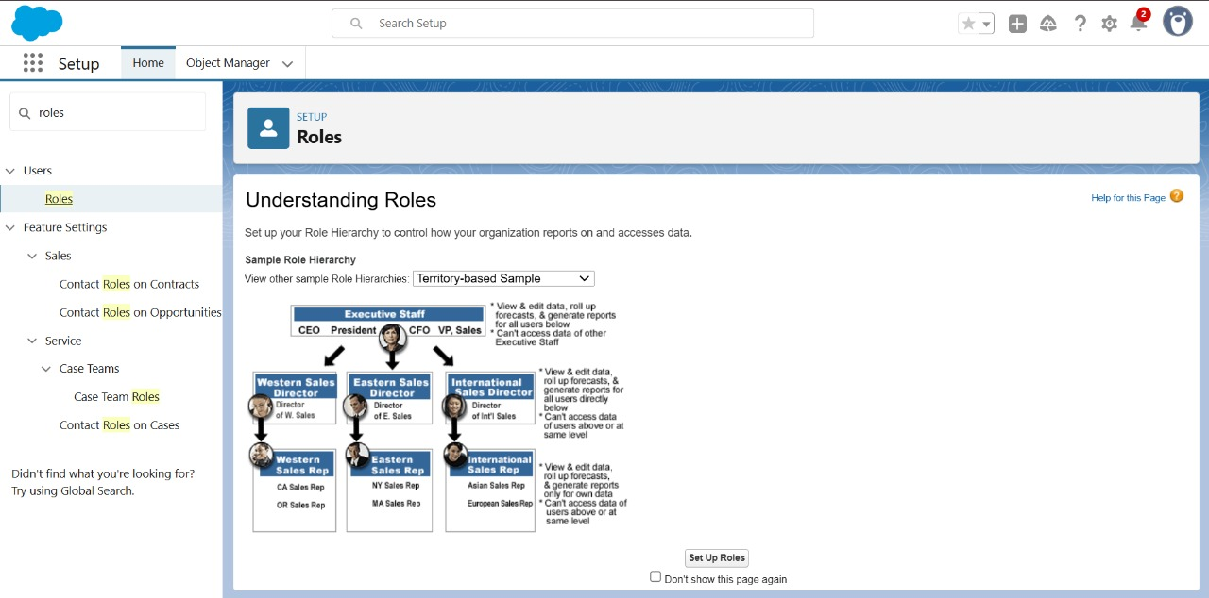

**Users:**

Users in Salesforce are individuals who have access to the Salesforce organization. Each user is assigned a profile that defines their permissions, and they can be assigned to one or more roles within the role hierarchy to determine their access to records. Users can have additional configurations such as permissions sets, licenses, and other settings that further define their capabilities within Salesforce.

**Created Users:**

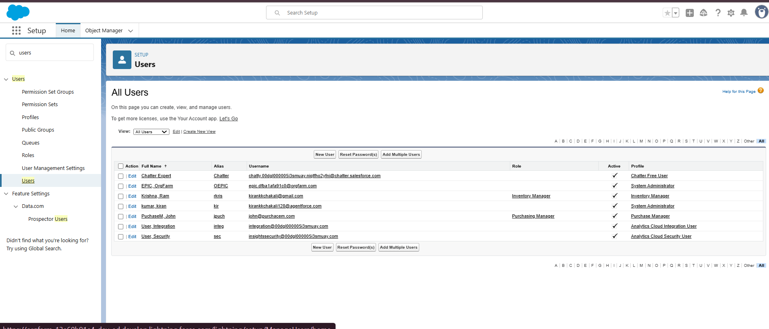

**Permission Sets:**

Permission Sets in Salesforce are a powerful tool to extend user permissions beyond what is defined in their profiles. They allow administrators to grant additional access to various tools and functions without altering the user's profile. Permission sets are particularly useful for providing specialized permissions to specific users without the need to create multiple profiles.

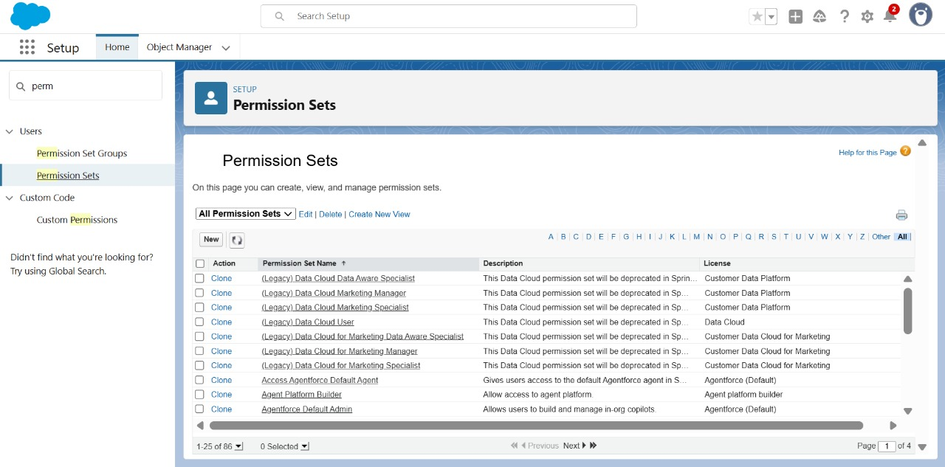

**Created Permission set:**

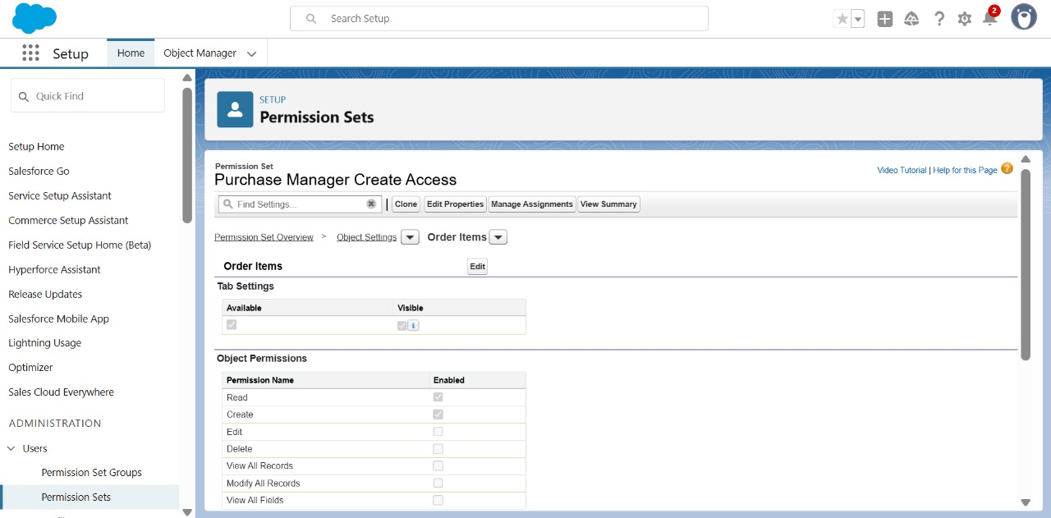

**Flows:**

Flows in Salesforce, part of the Lightning Flow product, are powerful automation tools that help you collect data and perform actions in your Salesforce environment. Flows can be used to automate business processes, guide users through tasks, and integrate with external systems. They are highly versatile and can be configured to meet a wide range of business requirements without the need for custom code.

**Created Flow to update the Actual Delivery Date:**

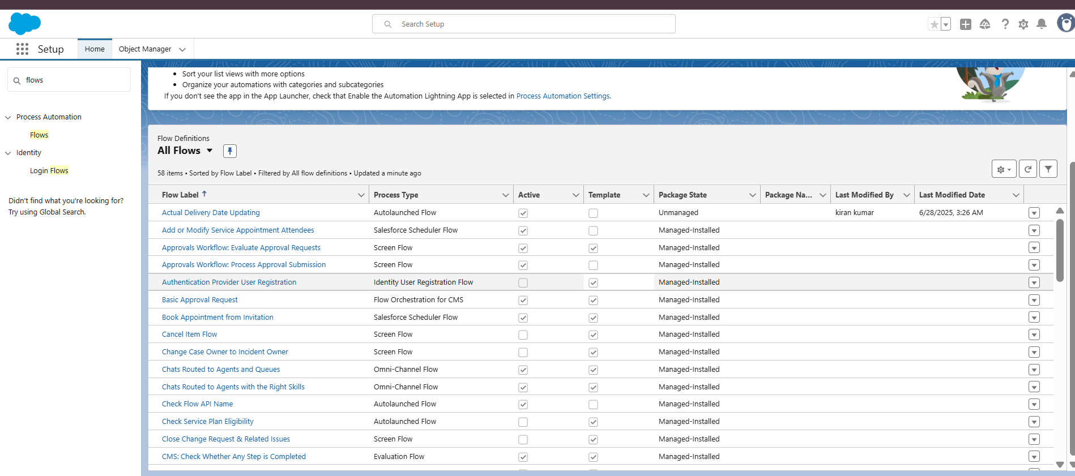

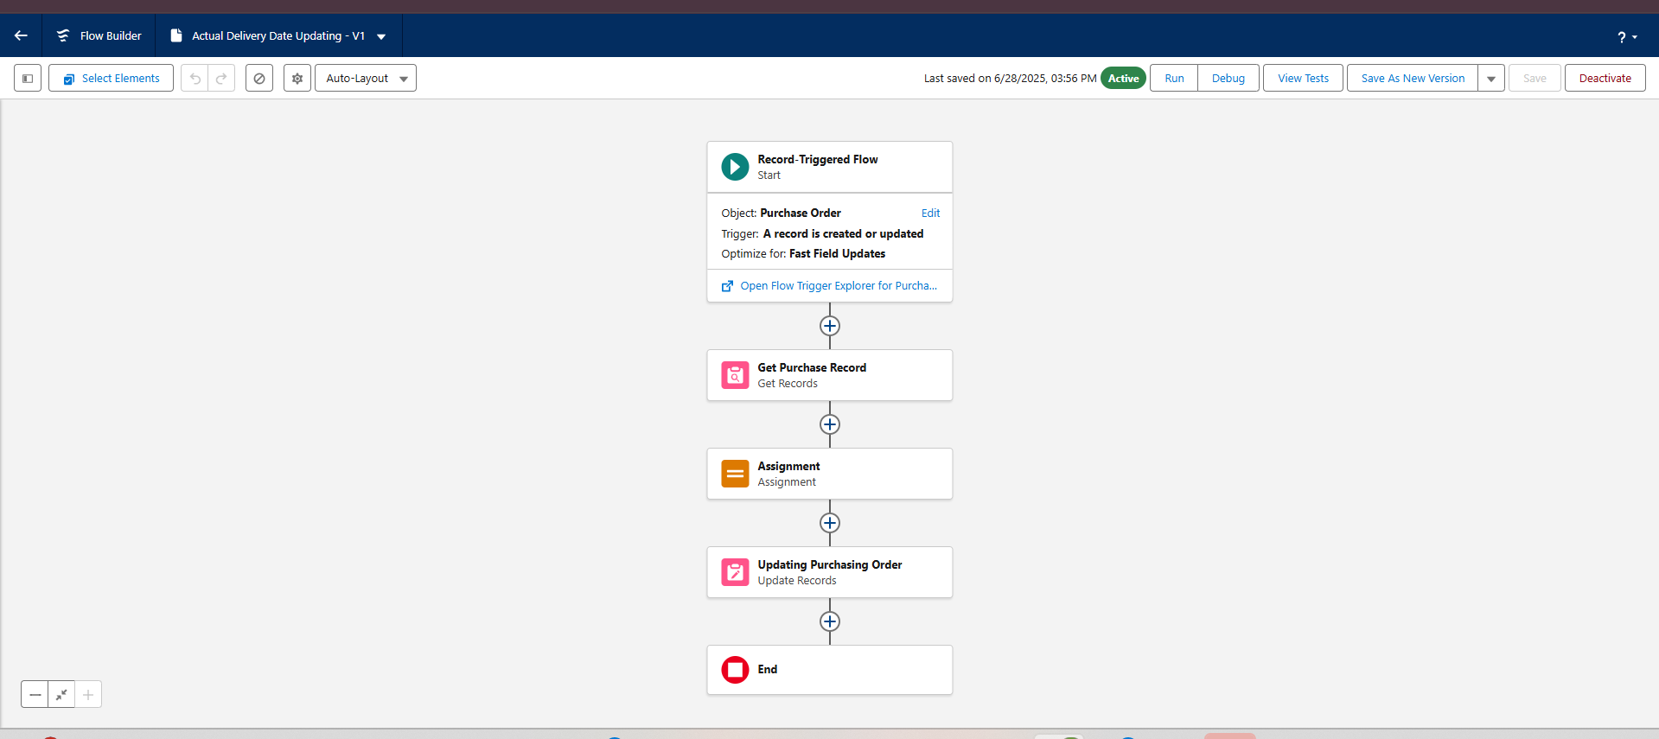

**Triggers:**

Triggers in Salesforce are pieces of Apex code that execute before or after specific data manipulation events on Salesforce records, such as insertions, updates, deletions, and undeletions. They are powerful tools for automating complex business logic and ensuring data integrity by enforcing custom validation rules and workflows that cannot be achieved through declarative tools alone.

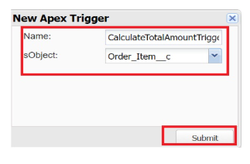 **Created a Trigger to Calculate total amount on Order Item:**

**Reports:**

Reports in Salesforce provide a powerful way to visualize and analyze data stored in your Salesforce organization. They allow users to create, customize, and share different types of reports based on data from standard and custom objects. Reports help organizations make informed decisions by providing insights into key metrics, trends, and performance indicators.

**Created Reports:**

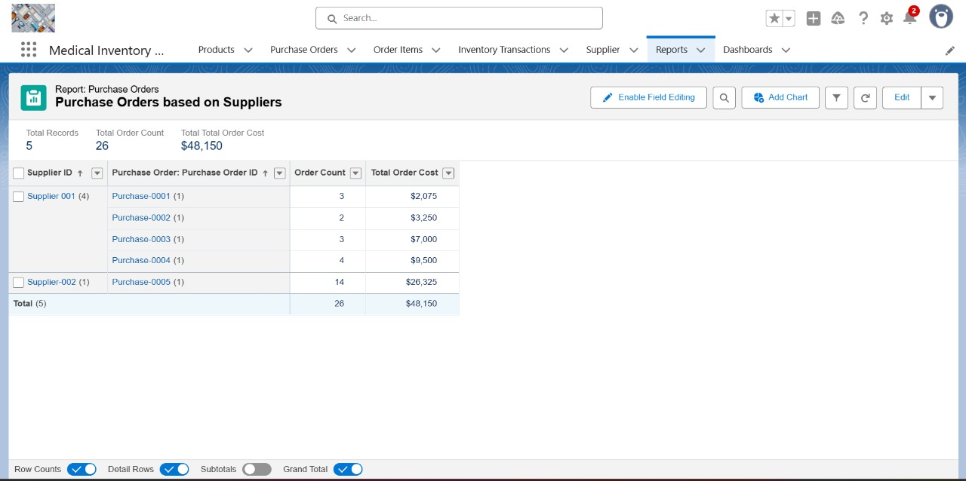

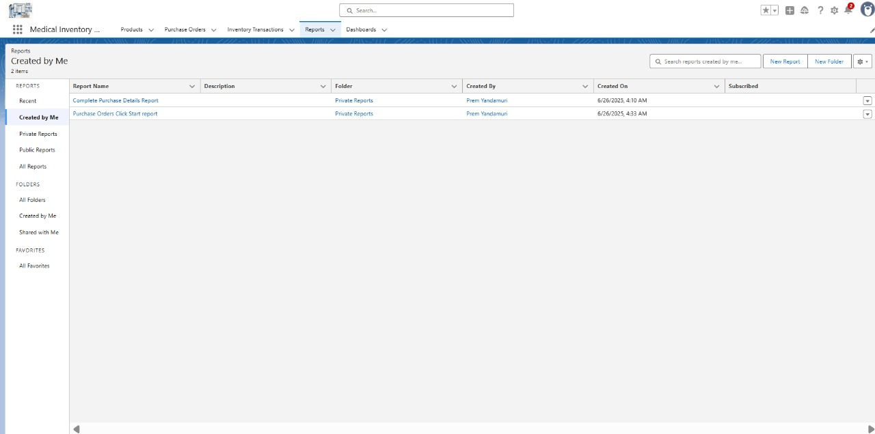

**Dashboards:**

Dashboards in Salesforce are dynamic visual representations of key metrics and data from reports, providing a consolidated view of organizational performance and trends. They are powerful tools for monitoring real-time data, tracking progress towards goals, and gaining actionable insights at a glance. Dashboards consist of components such as charts, tables, metrics, and gauges that display data from underlying reports.

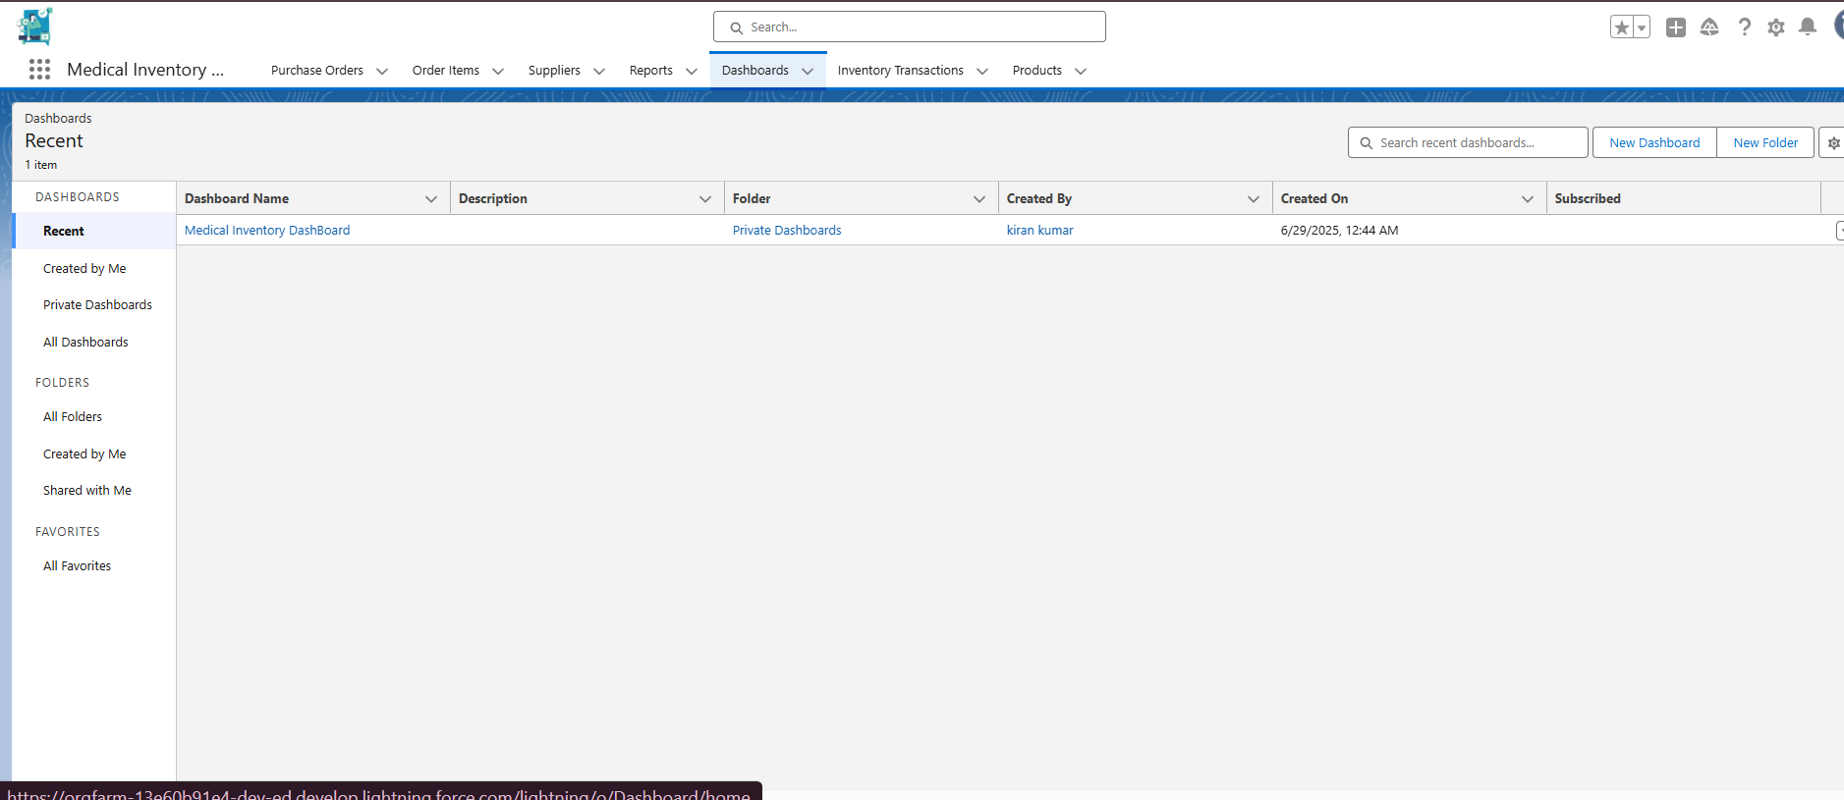

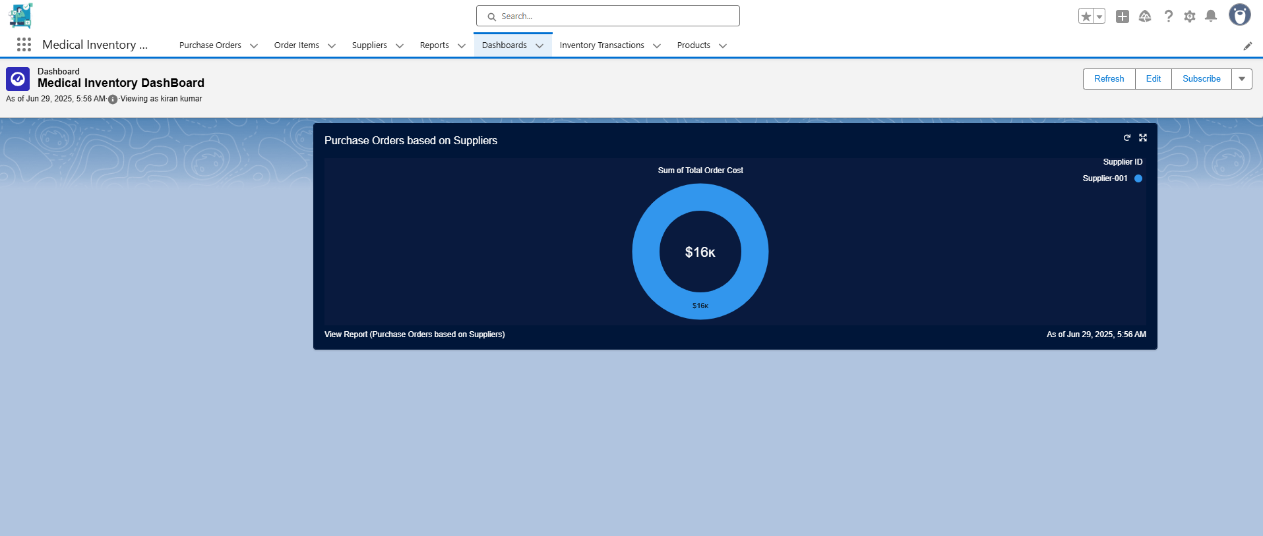

**6. FUNCTIONAL AND PERFORMANCE TESTING**

# Performance Testing:

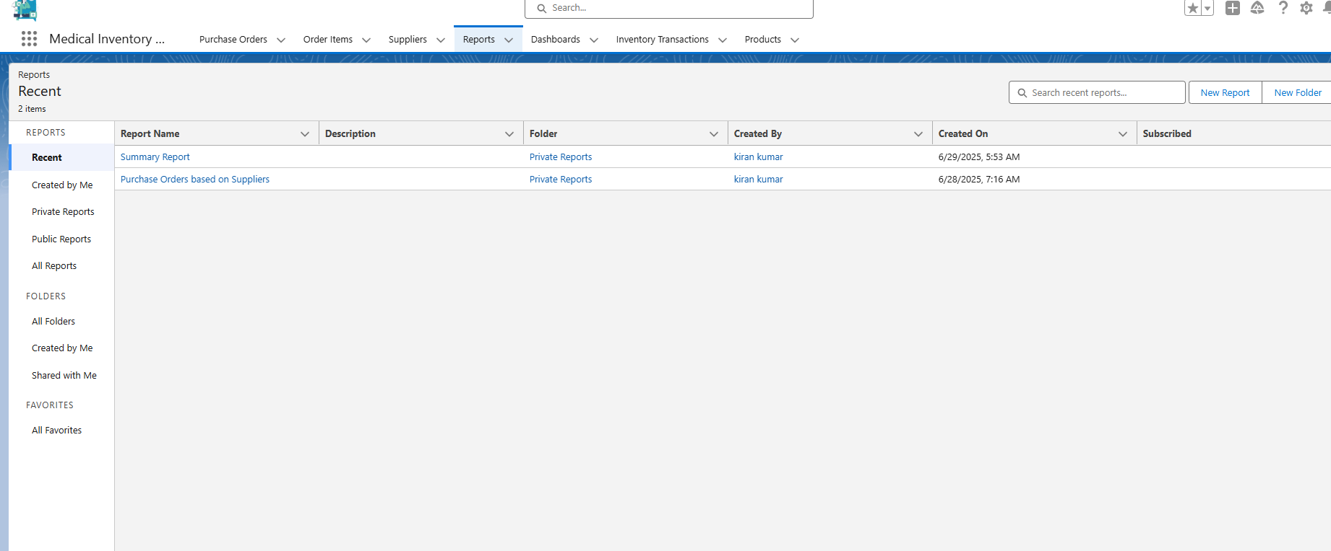



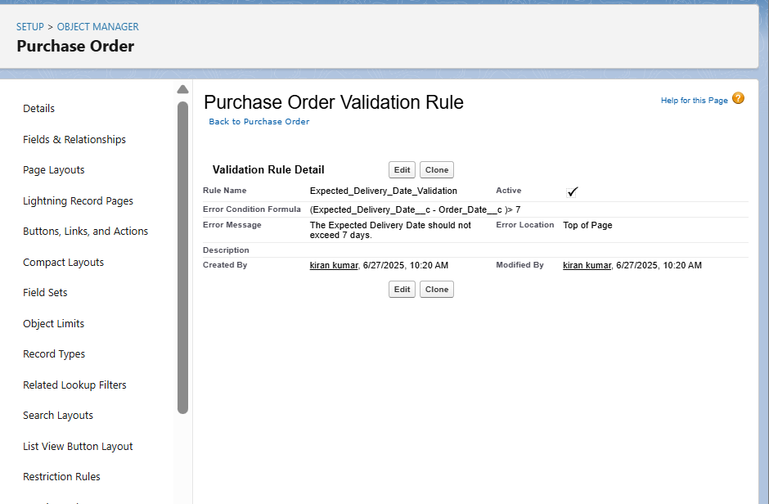

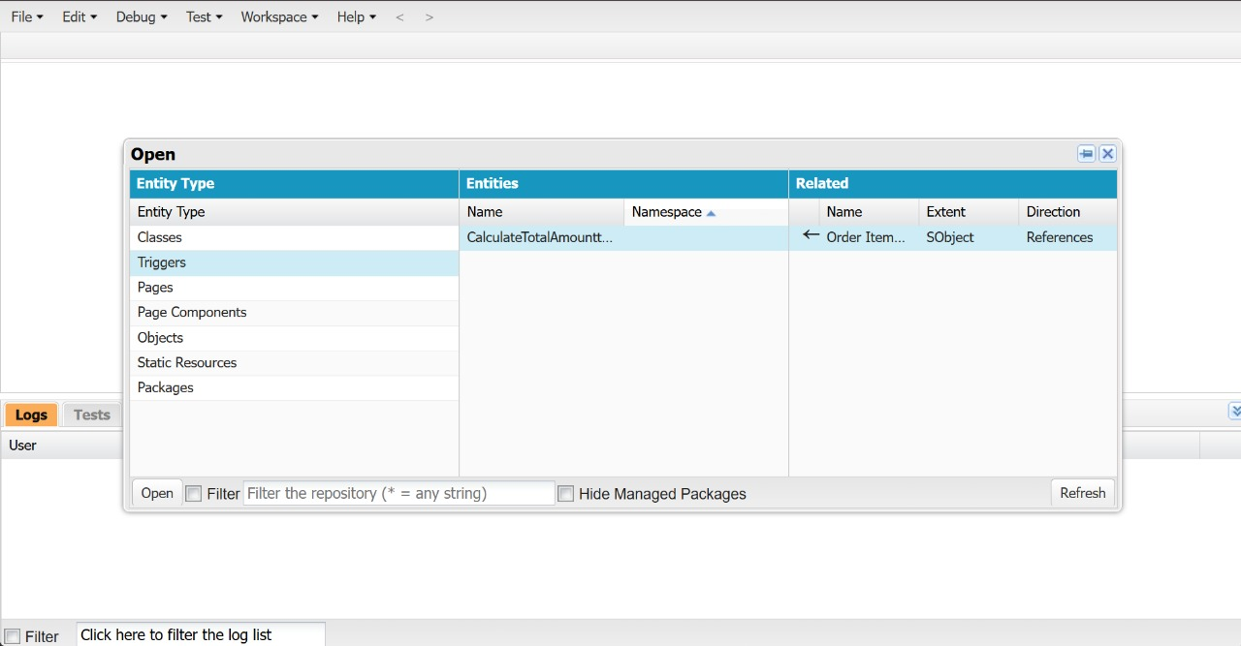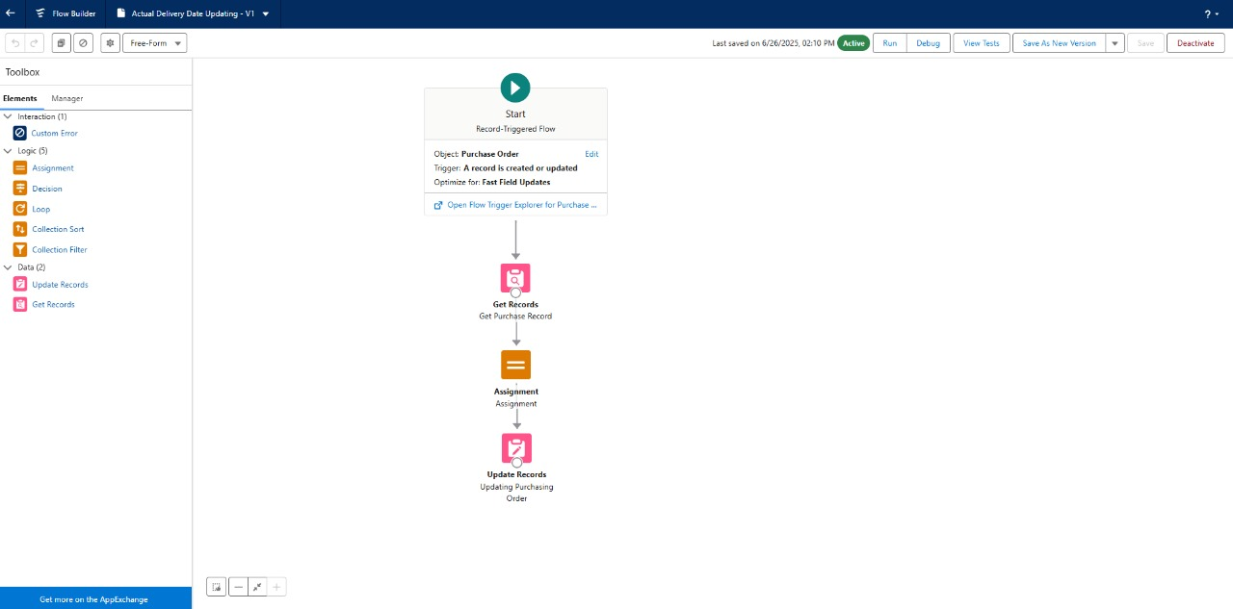

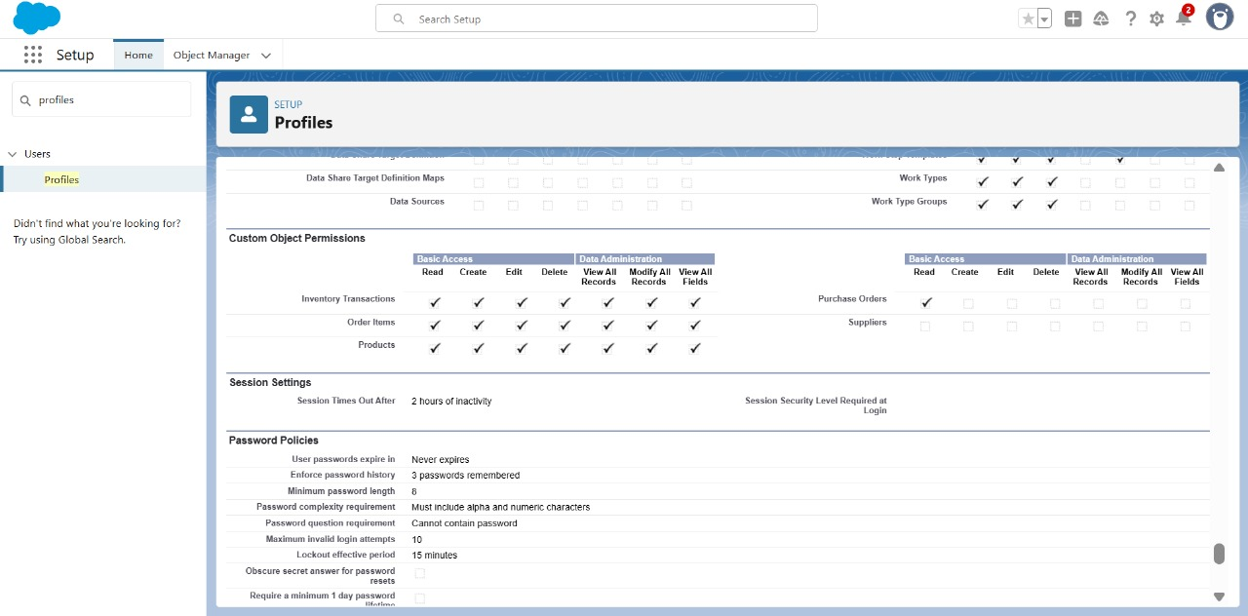

**7. RESULTS**

# **Output Screenshots:**



 v 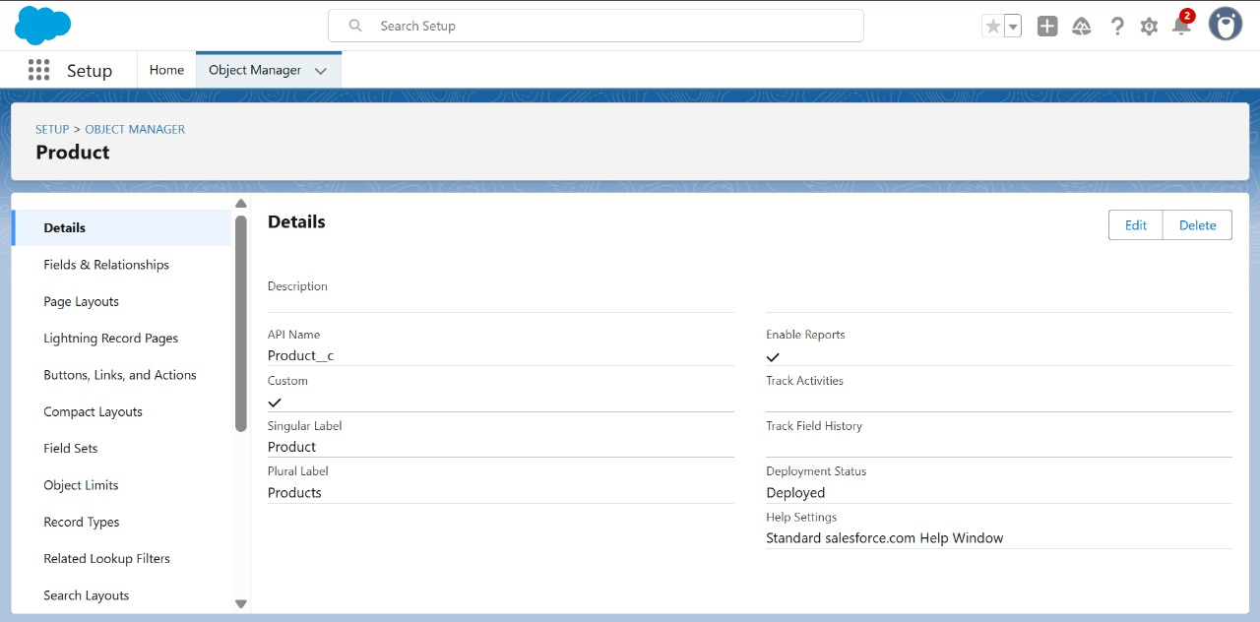     

**8. ADVANTAGES & DISADVANTAGES**

Here are the advantages and disadvantages of a Medical Inventory Management Project:

# **Advantages:**

**Advantages of the Medical Inventory Management System**

* **Improved Accuracy**
* Minimizes human errors in recording stock levels, tracking expiry dates, and processing reorders.
* **Real-Time Inventory Tracking**
* Provides live updates on stock availability and movements, enabling faster and more informed decision-making.
* **Cost Efficiency**
* Prevents overstocking and understocking, helping to reduce waste and control unnecessary procurement costs.
* **Enhanced Patient Safety**
* Automatically flags expired or unavailable medications, ensuring safer treatment practices and reducing risk to patients.
* **Regulatory Compliance**
* Maintains precise records that align with healthcare standards, making it easier to pass audits and meet regulatory requirements.
* **Operational Efficiency**
* Automates repetitive tasks such as restock alerts and inventory updates, freeing up time for healthcare personnel.
* **Data-Driven Decision Making**
* Generates detailed reports and analytics that support accurate forecasting, budget planning, and resource allocation.

# Disadvantages:

**Disadvantages of the Medical Inventory Management System**

* **High Initial Investment**
* Requires upfront costs for system setup, including licensing, hardware (e.g., barcode scanners), and staff training.
* **Risk of System Downtime**
* Technical failures or software outages can temporarily disrupt access to inventory data, affecting operations.
* **Integration Challenges**
* Incorporating the system with existing hospital or ERP systems may require additional development and customization efforts.
* **Training Requirements**
* Effective use of the system depends on proper training for pharmacists, nurses, and administrative staff.
* **Cybersecurity Threats**
* As a digital solution handling sensitive data, the system must be secured against potential cyber-attacks and data breaches.
* **Technology Dependence**
* Heavy reliance on the system means that any malfunction could significantly impact daily operations, especially in emergencies.

.

**9. CONCLUSION**

# **Conclusion:**

**Implementation & Conclusion**

The implementation of a **Medical Inventory Management System** marks a critical advancement in modernizing healthcare operations. It provides a structured, automated, and scalable solution for efficiently managing the diverse and complex inventory requirements of healthcare facilities—including medicines, equipment, and consumables.

By enabling **real-time tracking**, **automated alerts** for low stock and expiration dates, and **comprehensive reporting**, the system significantly improves operational accuracy and efficiency. One of its most impactful advantages is the **reduction of manual errors**, which commonly lead to serious issues such as stockouts, overstocking, or the inadvertent use of expired medical supplies.

Improved inventory control ensures that the **right medical products are available at the right time**, directly supporting better patient care and safety outcomes.

In addition, the system enhances **regulatory compliance** by maintaining complete and accurate records, which can be easily retrieved during audits and inspections. This capability supports healthcare organizations in meeting both national and international standards. The availability of **data-driven reports and analytics** empowers administrators to make informed decisions regarding procurement, budgeting, and inventory optimization—leading to long-term operational cost savings.

**Challenges and Considerations**

Despite its many advantages, the implementation of such a system is not without challenges:

* **High initial investment** in software licenses, hardware (e.g., barcode scanners), and comprehensive staff training.
* **Technical integration requirements**, especially when aligning with pre-existing hospital or ERP systems.
* **Cybersecurity concerns**, as the system stores sensitive information related to medical supplies and patient safety.

**Final Thoughts**

Nonetheless, with proper **planning**, **system maintenance**, and **ongoing staff training**, these challenges can be effectively managed. Over time, the benefits of the system—such as streamlined operations, improved compliance, and enhanced patient safety—greatly outweigh the initial constraints.

**Conclusion**

In conclusion, the successful implementation of a **Medical Inventory Management System** is essential for healthcare institutions seeking to improve accuracy, efficiency, and accountability in inventory operations. It not only optimizes internal workflows but also strengthens patient care quality and organizational compliance. In today’s fast-evolving medical landscape, such systems are no longer optional—they are fundamental to delivering high-standard, reliable, and cost-effective healthcare services.

**10. FUTURE SCOPE**

# **Future Scope of Medical Inventory Management:**

The Medical Inventory Management System has vast potential for future growth and development. As healthcare needs continue to evolve, the system can be expanded and enhanced to provide even greater efficiency, accuracy, and integration with emerging technologies. Some of the key future directions and opportunities include:

1. Integration with IoT (Internet of Things)

* Smart shelves, RFID tags, and IoT-enabled sensors can be used to automatically detect stock levels and environmental conditions like temperature and humidity, which are critical for sensitive medicines and vaccines.
* Real-time automated stock updates without manual intervention.

2. Artificial Intelligence (AI) and Predictive Analytics

* AI can be used for demand forecasting, helping hospitals predict future inventory needs based on patient inflow, disease outbreaks, and historical consumption patterns.
* Predictive alerts for possible shortages, stock expiration, and replenishment scheduling.

3. Mobile Accessibility

* Future systems can offer fully mobile applications for on-the-go inventory checks, approvals, and stock updates, improving accessibility for medical staff.
* Real-time push notifications for urgent stock alerts on mobile devices.

4. Blockchain Integration for Enhanced Security

* Blockchain can be used to track the entire supply chain of medical products, ensuring authenticity and reducing counterfeit risks.
* Immutable transaction records can improve traceability and trust.

5. Cloud-Based Solutions

* Moving the system to the cloud will allow scalability, remote access, and centralized data management.
* It will also reduce infrastructure costs and simplify system maintenance.

6. Automatic Supplier Reordering

* Integration with supplier systems to enable automated purchase orders when stock reaches minimum levels.
* Reduces delays in procurement and ensures continuous availability of critical items.

7. Advanced Reporting and Dashboards

* Future systems can offer customizable dashboards and real-time visual analytics to assist hospital administrators in making faster and more informed decisions.

8. Enhanced Cybersecurity Measures

* As more data becomes digitized, stronger cybersecurity frameworks will be essential to protect sensitive medical inventory and patient data from potential cyber threats.

9. Multi-Location and Multi-Branch Inventory Synchronization

* Ability to manage inventory across multiple hospitals, clinics, or warehouses from a single system.
* Supports easy transfer of stock between locations based on demand.

10. Sustainability Tracking

* Future systems can track medical waste, expired items, and promote eco-friendly inventory practices in line with sustainable healthcare goals.

**11. APPENDIX**

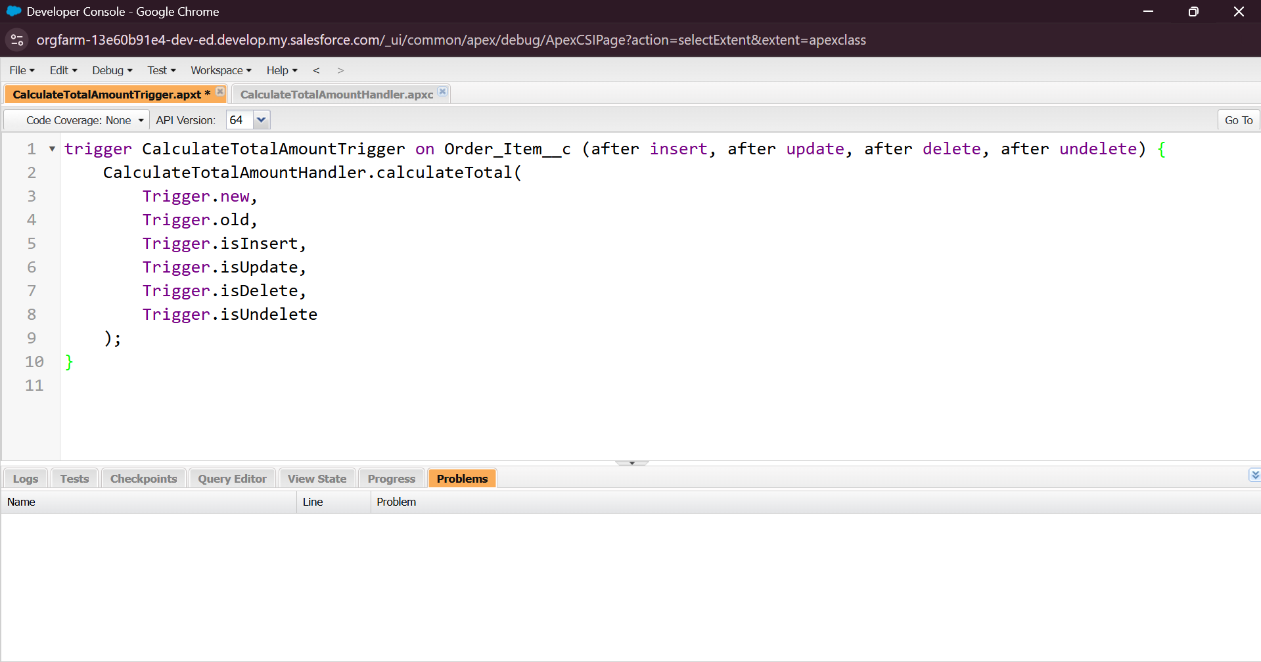**Source code:**

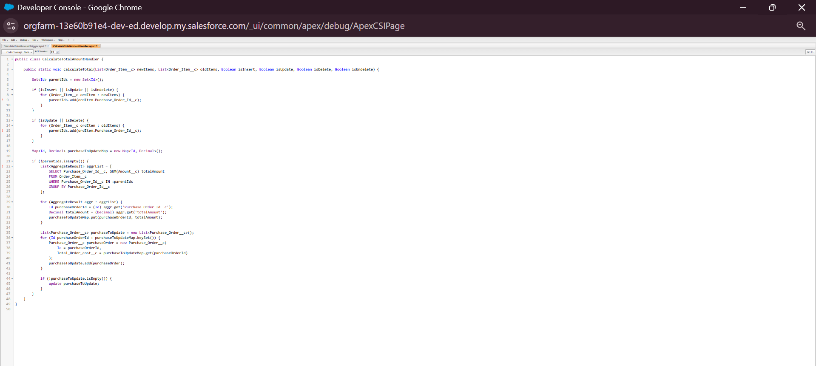

# **GitHub:**

# **Project Demo Link:**